**To boost availability, Nvidia may be preparing two new GeForce RTX 3050 variants**

The rumour mill says that while Nvidia's GeForce RTX 3050 checks most of the boxes for a mainstream graphics card, availability has been patchy. According to reports, the business is working on a solution to this problem, which might include more RTX 3050 variants based on the smaller GA107 chip.

Nvidia's GeForce RTX 3050 debuted last month to rave reviews, giving a significantly stronger first impression than AMD's RX 6500 XT. Unfortunately for many potential customers, it sold out in a matter of hours, and the price rose to unacceptably high levels. The fact that Nvidia chose to employ a scaled-down version of the GA106 device from the RTX 3060, which is relatively huge and expensive, is part of the problem.

Because there are only so many GA106 dies that can fit on a wafer, the choice was likely influenced by Samsung's 8nm manufacturing node's low yield. In other words, it's possible that Nvidia is reusing damaged RTX 3060 dies to make RTX 3050 graphics cards, therefore availability is still an issue.

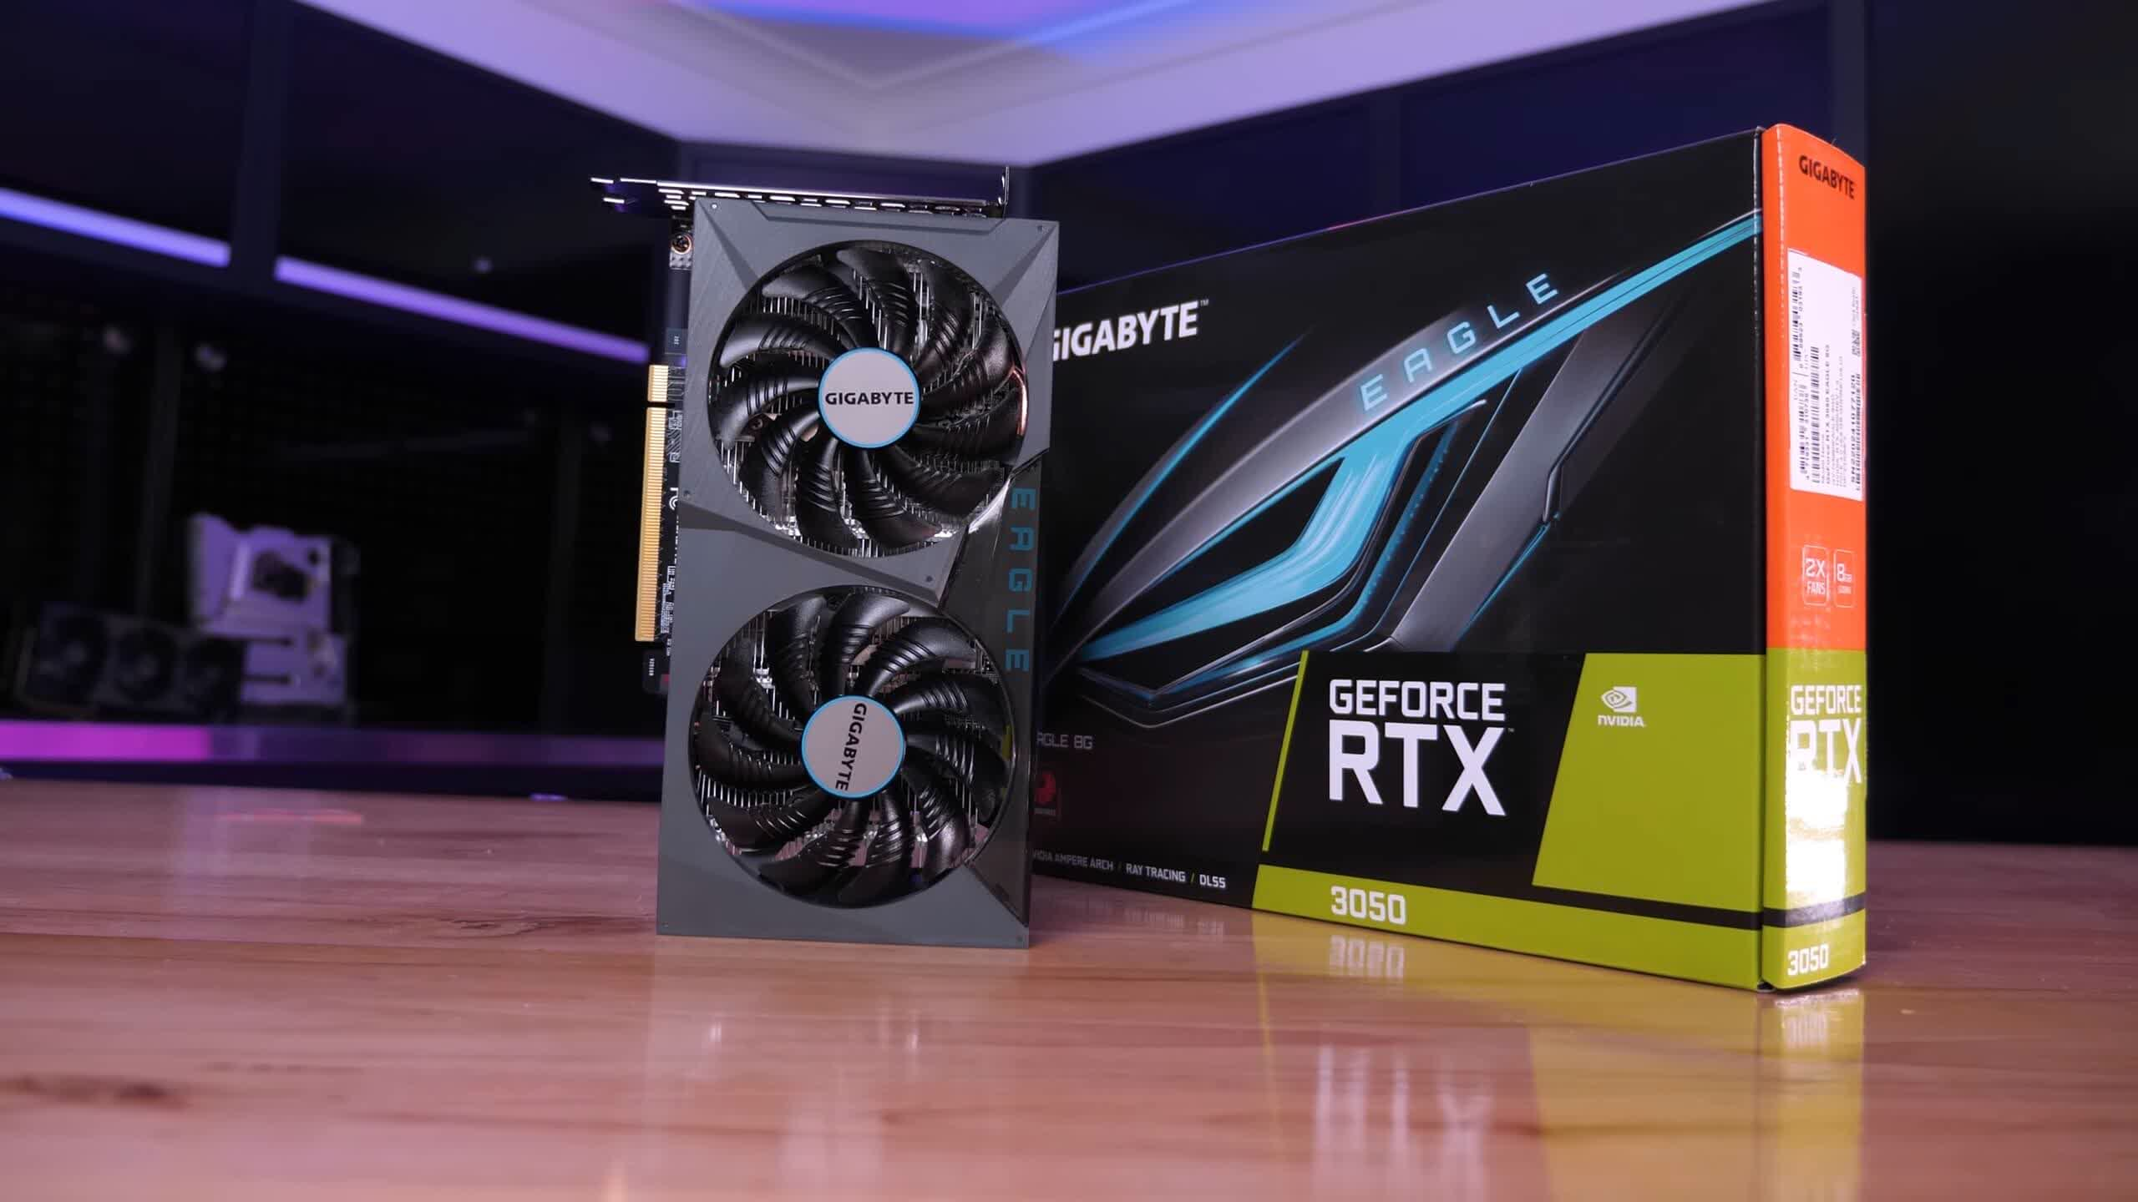

However, Nvidia is said to be working on at least two other versions, both of which could be based on the GA107 chip. This is the same little Ampere die that powers RTX 3050 laptop graphics solutions, therefore it could have slightly lower power consumption than the current RTX 3050 desktop card.

The GA107 chip has 2,560 CUDA cores, 80 TMUs, 32 ROPs, 80 Tensor cores, and 20 RT cores, as well as a 128-bit memory bus and eight PCIe 4.0 lanes, just like the GA106-150. But, more crucially, it's supposed to be pin-compatible with the latter section, making it simple for manufacturers to incorporate it into their existing PCB designs.

According to a recent TechPowerUp entry (discovered by Twitter user @harukaze5719), Nvidia is also working on an RTX 3050 model with only 4 GB of GDDR6, likely to match a lower $199 pricing goal. This could be Team Green's response to AMD's RX 6500 XT graphics card, which isn't particularly enticing to miners but is relatively simple to mass-produce.